**PRIMARY ONE EXAMS**

**ENGLISH MID TERM THREE 2024**

**TIME ALLOWED: 2HRS 15MINS**

Name: ………………………………………………………………………………

**SECTION A**

1. **Write these words correctly**

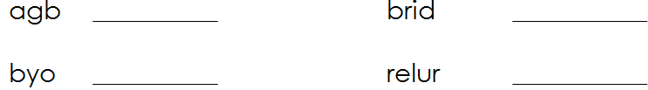

1. **Use ‘an’ or ‘a’**

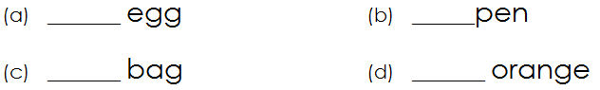

1. **Circle the correct word for the picture**

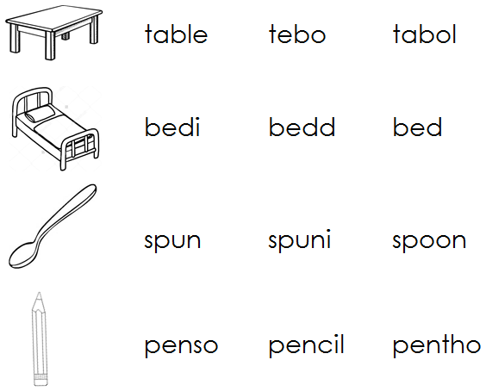

1. **Use a correct word to fill the gaps.**

(a) Sarah is using a broom to __________________ the compound.

(b) That girl has lost _____________ books.

(c) The boy is going _____________ school.

(d) James is eating ________________ orange,

(e) My friends ________________ big bags.

1. **Arrange the words in alphabetical order**
2. goat, sheep, cow, dog

_____________________________________________________

1. boat, cyclist, aeroplane, donkey

______________________________________________________

1. **Use the words below to make sentences**

|  |  |  |
| --- | --- | --- |
| (a) | These: | _____________________________________________ |
| (b) | This: | _____________________________________________ |

1. **Give the plural form of the underlined words.**
2. My **box** is heavy. _______________________
3. Father loves the **baby**. _______________________
4. The **girl** is playing in class. _______________________
5. **Write a small word from the big one.**

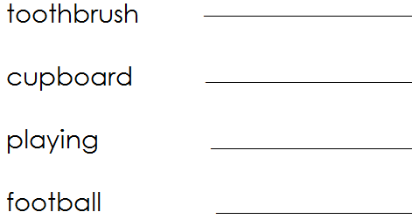

1. **Use ‘Yes, it is’ or ‘No, it is not’**

|  |  |
| --- | --- |
|  | Is this a book?  ___________________________________________ |
|  | Is this a blackboard?  ___________________________________________ |
|  | Is this a ruler?  ___________________________________________ |
|  | Is this a ruler?  ___________________________________________ |

1. **Write the opposite of the following.**

a) grandfather ____________________

b) sad ____________________

1. **Make four correct sentences from the table below.**

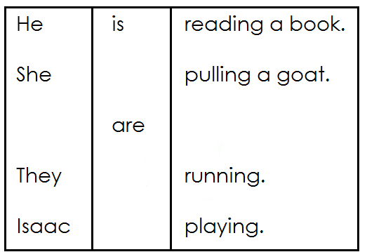

1. ______________________________________________________
2. ______________________________________________________
3. ______________________________________________________
4. ______________________________________________________
5. **Re-arrange the words to make correct sentences.**
6. My is fahter a teacher.

________________________________________________________

1. eating is Jane fish.

________________________________________________________

1. crying Why you are ?

_________________________________________________________

1. **Match correctly.**

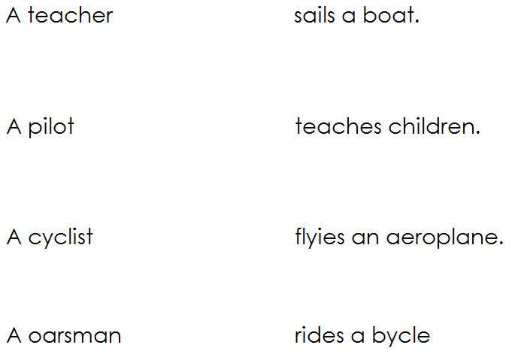

1. **Read and draw.**

|  |  |
| --- | --- |
| **This is a chair.** | **These are pots.** |
|  |  |
| **I can see a tree.** | **Those are books.** |
|  |  |

1. **Read the story and answer the questions.**

My name is Nelson. I live at Njeru. I am in P.1 at Mukono Primary School. My best friend is Peter. I like him because he is a good boy.

1. In which school is Nelson?

________________________________________________________

1. Who is Nelson’s best friend?

________________________________________________________

1. Nelson lives at __________________________________________
2. Nelson likes Peter because he is a ________________ boy.
3. Write a small word from;
4. Good boy ___________________________

***THE END***